Investment process

Our investment philosophy is a computer-driven method for capitalizing on crypto markets. We deliver active returns (alpha) to our clients with programmatically executed solutions. At Insula we believe that the cryptocurrencies market is inefficient. By operating on this market, Insula both provides and benefits from a deeper liquidity, better price discovery and a narrower market bid-ask spread, all together with an increased certainty of execution. We thereby improve the ability of financial markets to allocate capital to its most productive uses. Both strategy (portfolio management) and execution (trading) is performed by algorithms.

Our investment process is ran by algorithms to allow investors to get rid of any form of bias that hinder decision making.

Although people are subject to making biased decisions, computers are designed to only make rational decisions.

**INVESTORS APPETITE FOR THIS NEW ASSET CLASS**

**The new and vibrant face of collectibles.**

In the last decade, investors have been relentlessly trying to find new ways to diversify risk from their portfolios. Since the rise of cryptocurrencies, numerous studies from top academics have found cryptocurrencies to be a very effective way of diversifying big chunks of risk from their portfolios.

At Insula we think cryptocurrency investment can be considered similar to investments in collectibles and may attract the same family of investors i.e. high net worth individuals. A collectible is any physical asset that appreciates in value over time because it is rare or desired by many such as stamps, coins, fine art, antiques, books, and wine.

**Cryptocurrencies: here to stay**

Many believed that cryptocurrencies weren’t going to last long but we think otherwise. The Central Limit Theorem and the Lindy Effect studied together announce a promising era for cryptocurrencies and their effect on diversification in asset management. The Jay Waldemar Lindeberg’s Central Limit Theorem states that the more time a thing spends near the center of a normal distribution, the more likely it is to remain near the center of the distribution in the future. The Lindy effect is a state that the future life expectancy of some non-perishable things (e.g. technology or an idea) is proportional to their current age, so that every additional period of survival implies a longer remaining life expectancy. Where the Lindy effect applies, mortality rate decreases with time.

In fact, the Lindy effect holds with Bitcoin as the crypto-asset market exhibits continuous extinction pressure on assets and protocols. The cryptocurrency market has now a track record of several years and there are no signs of it slowing down.

### **WHAT IS OUR THEORETICAL INVESTMENT SUPPORT?**

**Modern Portfolio Theory or “MPT”**

***Background***

Until the publication of MPT by Harry Markowitz in 1952, investment decisions were based on identifying securities with the highest return and at less risk, then they were included in the investment portfolio. Markowitz offers another approach called diversification, where construction of the portfolio is made after evaluation of the overall portfolio risk instead of merely compiling portfolios from securities that each individually has attractive risk reward characteristics. Simply put, Modern Portfolio Theory is built on the idea that risk-averse investors can construct portfolios to optimize or maximize expected return for a given level of risk by simply altering the proportions of fund allocation across assets.

***Inputs of the model***

The main inputs of this model are the historical returns of the selected assets. The model uses the average return of each asset as its expected return. With these data, the model then computes the correlations between all the assets, which are used to determine the expected level of risk for the entire portfolio. These correlations are expressed as numbers between -1 and 1. Numbers close to 1 indicate that assets tend to move in the same direction, numbers close to 0 indicate that there is no relation between the assets, and numbers close to -1 indicate that assets tend to move in opposite directions.

***Parameters of the model***

The parameters of the model are the individual weights of each asset in the portfolio, expressed in percentage terms. However, portfolio managers usually determine constraints to these parameters to limit the optimization results to viable portfolios. Usually, these constraints include no negative weights (i.e. no short positions) and a sum of weights equal to 100% (i.e. no leftover cash or leverage). Note that additional constraints can be included depending on the objectives and limitations of portfolio managers.

***Efficient frontier***

With all these in place, the model constructs a large number of different possible portfolios by combining security and by varying proportion of investment among assets and the collection of all such possible portfolios defines a region in this space. Among the portfolios formed, some are efficient, and many others are inefficient. The sets of portfolios that (i.) offer maximum expected return for varying levels of risk, and (ii.) offer minimum risk for varying levels of expected return, are known as "efficient sets". The line along the upper edge of this region is known as the efficient frontier. Combinations along this line represent optimal portfolios (explicitly excluding the risk-free alternative) for which there is lowest risk for a given level of return. Within this frontier, the model can also find the portfolio with the maximum Sharpe Ratio — that is to say, the portfolio with a higher return per unit of risk. Mathematically the efficient frontier is the intersection of the set of portfolios with minimum risk and the set of portfolios with maximum return.

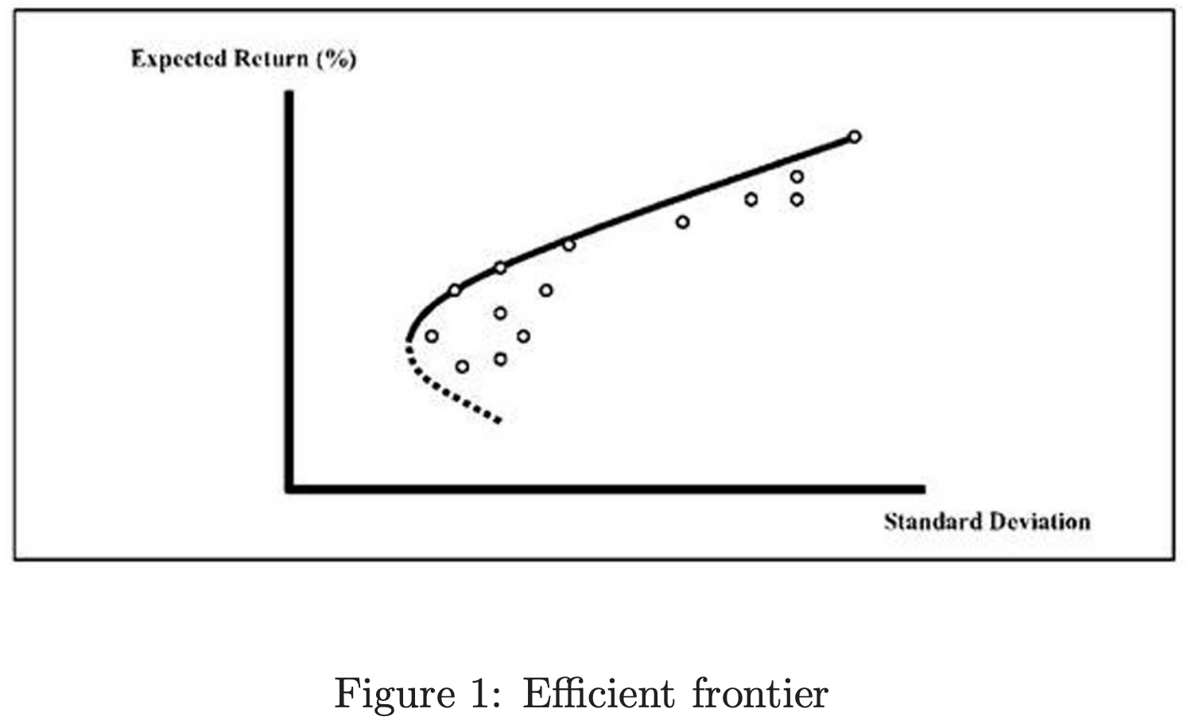

***Markovitz optimization***

The portfolio optimization plays an important role in determining the portfolio strategies for investors. What investors hope to achieve through a portfolio optimization is to maximize portfolio return and minimize portfolio risk. Since the return changes based on risk investors have to balance the contradiction between risk and return for their investment. There is therefore no single optimized portfolio to satisfy all investors. The optimal portfolio is determined by the preferences of the investor’s risk and return

***Diversification***

MPT states that with increasing number of assets in the portfolio, the corresponding number of correlations becomes significantly larger than the number of assets and therefore the risk of the portfolio will mostly depend on covariances between assets rather than on risk of individual assets. Therefore, to reduce the overall risk of the portfolio, investment should choose assets that have little to no correlation. Hence, the essential aspect pertaining to the risk of an asset is the contribution of each asset to the risk of the aggregate portfolio.

***Assumptions of Markovitz model***

The Markowitz model is based on several assumptions concerning the behavior of investors and financial market.

* A probability distribution of possible returns over some holding period can be estimated by investors.
* Investors have single-period utility functions.
* Average past returns standard deviation is used by investors to measure risk.
* Investors care only about the means and standard deviations of the returns of their portfolios over a particular period.
* Return is desirable; risk is to be avoided.
* Financial markets are frictionless.
* There is no transaction cost or taxes.

**Limits of MPT**

The historical mean return may be a poor estimate of the future mean return. As you increase the number of securities, you increase the number of correlations you must estimate – and you must estimate them correctly to obtain the right answer. For large number of stocks, one is certain to find correlations that are widely inaccurate. Unfortunately, the model does not deal well with incorrect inputs. To tackle that issue, we connect to many crypto-asset exchanges which offer us with plenty of price time series.

Also**,** the computations required are numerous and complex in nature. With a given set of securities, an infinite number of portfolios can be constructed. The identification of efficient portfolios requires the use of quadratic programming which is a complex procedure. Because of the difficulties associated with the Markowitz model, it has found little use in practical applications of portfolio analysis. Much simplification is needed before the theory can be used for practical applications. Simplification is needed in the amount and type of input data required to perform portfolio analysis; simplification is also needed in the computational procedure used to select optimal portfolios. At Insula, we master the IT process using in house know-how and decentralized computing infrastructure.

**How do we apply our theoretical support?**

Based on our theoretical support, we only use technology and quantitative methods, with 0 % discretionary intervention. Our investments are run by algorithms to allow investors to get rid of any form of bias that hinders decision making. This implies that automated signals through algorithms command trade on a low latency basis thanks to high frequency data tools. This process enables optimal price discovery across various trading venues.

***Investment style***

Insula’s investment style is straightforward. We do not try to beat the market or passively track the market, but rather invest quantitatively and systematically using rule-based and factorial investment techniques.

***Zoom on Rule-based investing***

While traditional indexes weight stocks by market capitalization, rule-based investing or “smart beta” weight stocks by non-market cap measures. A simple non-market stocks weighting measure is equal weighting, but that strategy requires holding equal weights in the smallest stocks, which may be hard to trade. Therefore, most smart beta indexes use other transparent and rule-based weighting techniques. They deviate from traditional cap-weighted indexes by reweighting stocks in a systematic manner based on well-defined factors such as relative price/earnings, relative volatility, momentum, quality, and other risk-based or market segment criteria.

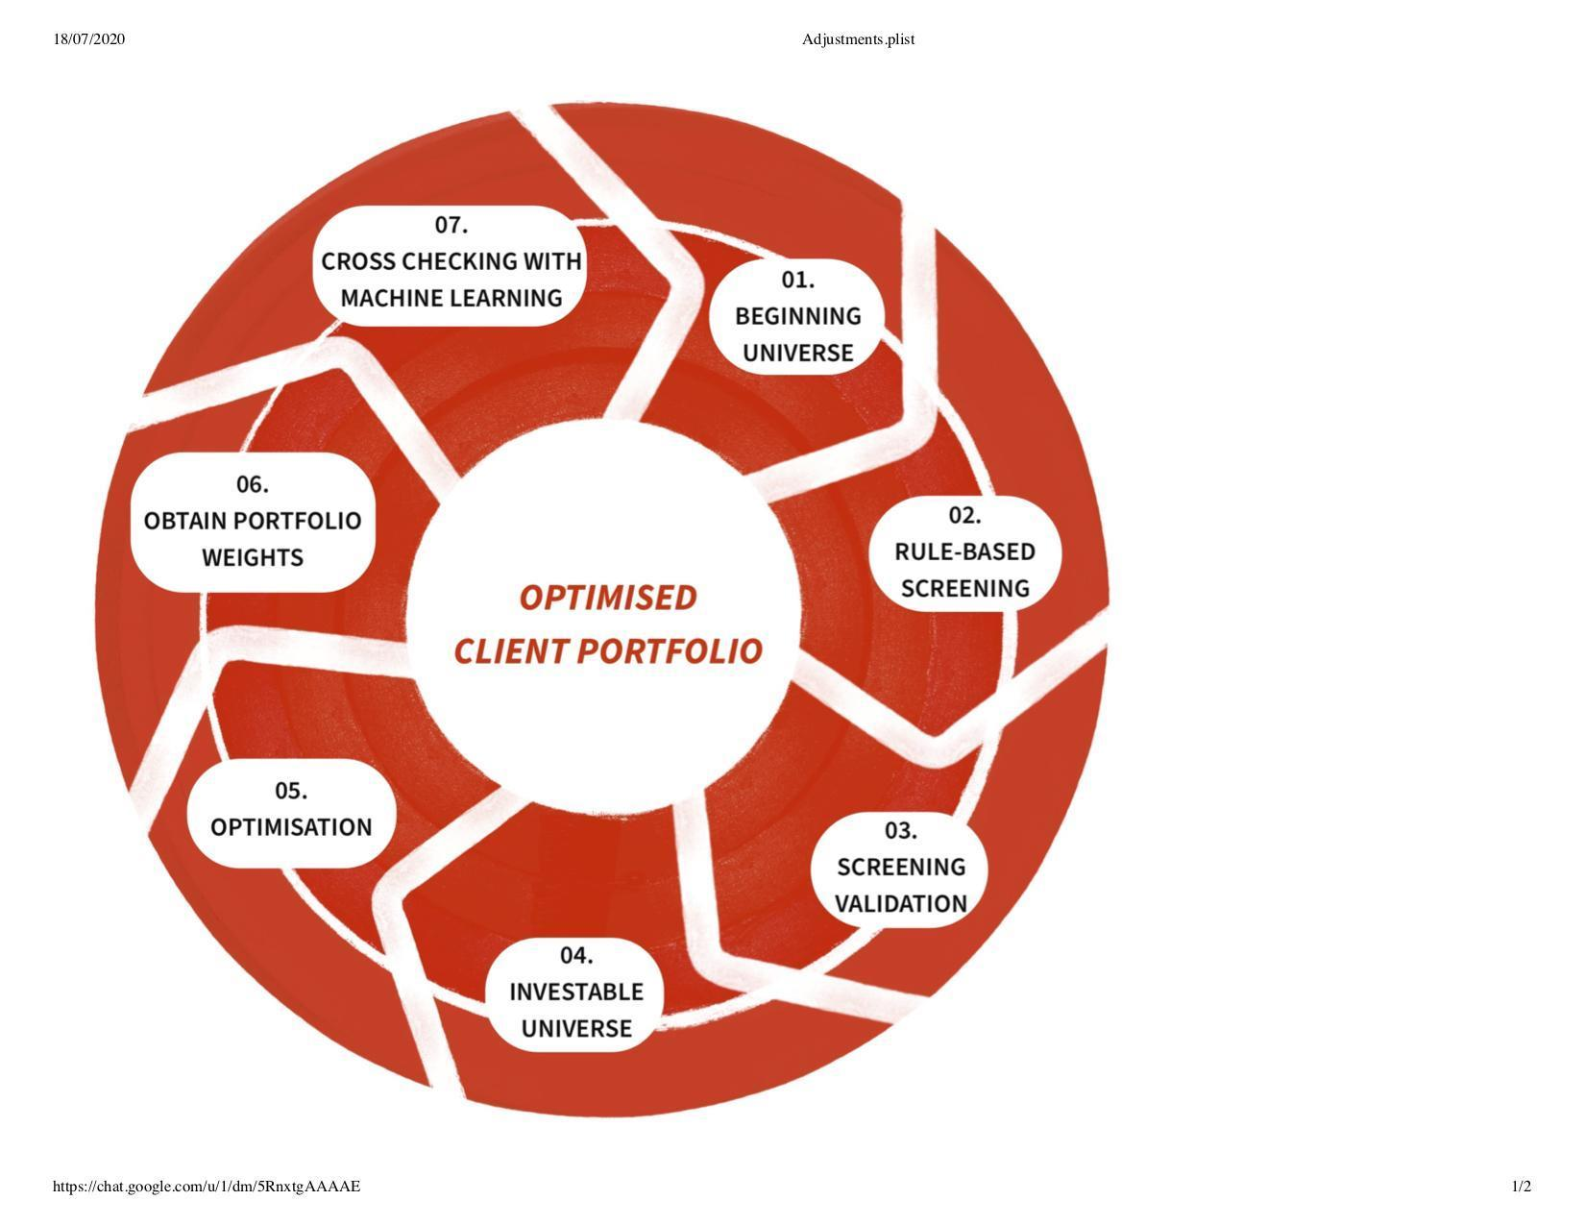***Investment process***

**STEP 1: Beginning Universe**

As of June 2020, the total number of cryptocurrencies reached 5,563 with a total market cap of $271.58 billion.

**STEP 2: Rule-based screening**

Since Insula investment funds only operate in decentralized coins in decentralized exchanges (Cotrader and Melon), Insula’s investment universe is filtered to 500 coins.

We then filter coins that have enough liquidity, a minimum of 500 days of trading in a decentralized exchange, who induce more than 20% slippage for orders bigger than 50ETH.

This part of the investment process directly eliminates worthless and illegitimate altcoins for our investable universe.

**STEP 3: Screening validation**

We then exclude from the investment universe the duplicates that have 1 to 1 price-correlation such as BTC & WBTC. In this case WBTC would be excluded so only BTC remains amongst the two.

**STEP 4: Investable universe** (input)**.**

We have now obtained our investable universe.

**STEP 5: Optimisation.**

We now run the Markovitz optimization model on our investable universe to find the efficient frontier and exclude the inefficient portfolios.

**STEP 6: Obtain portfolio weights** (output)**.**

After finding the various efficient portfolios, we will choose the portfolio that yields the highest excess returns for each unit of investment risk known as the optimal Sharpe ratio portfolio. This will be the fund’s portfolio. Investment weights will be changed on a monthly basis.

**STEP 7: Portfolio weights validation with cross-checking with machine learning software.**

We are still currently working on building that final optimization step. Once completed, the developed machine learning software would accurately forecast cryptocurrency returns using further quantitative input. That will help us make more informed investment decisions.

# **WHAT IS THE ROLE OF AUTOMATION POWER IN THE INVESTMENT PROCESS?**

***Investing decisions and Human Bias***

Investing decisions are influenced by our emotions more than initially thought. There is a real behavior gap between what investors should do and what they actually do. Indeed, between 1.4 and 4.3 per cent in annual returns is lost by investors because of their emotions influencing their trading strategy. Many of the world’s best investors have a high level of emotional regulation and treat their feelings as reverse indicators, e.g. Excitement is an indicator that it’s time to sell, fear indicates that it’s time to buy. Furthermore, evidence in brain imagery analysis has shown that the pursuit of small gains activates the prefrontal cortex, the center of rational decision-making. In contrast, the pursuit of big gains activates the Nucleus Accumbens, a region associated with pleasure and euphoria. Emotions, such as fear, competition and rewards, corrupt our rational decision-making.

Apart from emotions, genes and hormones are also thought to influence decision making. Indeed, Dr Nadler has demonstrated that a high level of testosterone-induced a more impulsive and reckless investing strategy leading to larger and long-lasting financial bubbles in simulation. In genetics, it is estimated that 25% of personal risk appetite is inherited, with a common risk attitude observed over twins.

Known as ‘cognitive bias’, our biology and psychology affect significantly but unconsciously our financial choices. For example, the “confirmation bias” makes investors seek information confirming their theory but overlook contradictory facts. While the” loss aversion” makes investors be psychologically impacted twice as much for a loss than for an equivalent value gain. Once these cognitive biases have been identified and understood, an individual can reduce only 30 percent of them.

Such automation ensures unbiased trading and optimization on the cryptocurrency market, for a better return for our investors.

**Human bias and the Insula cortex**

Humans' cognitive biases, especially the “loss aversion” bias, take roots in the Insula. This region of the brain is involved in self-awareness, fear, pain, anxiety, empathy. Overall the Insula modulates the intensity of felt emotions before sending them to the cognition treatment of information. The Insula links the rational system with the emotional system.

Previous studies have proven that the Insula was less active in traders of stocks compared to people that stand away from financial risks. The latter was taking more conservative decisions and fearing the unknown. So, the Insula perceives and represents expected risks, interferes with rational judgment, and guides decision-making under uncertainty.

***Machine automation***  
Machine automation would help bypass human bias by creating a fair, honest and more performant system. With an algorithm, hormones, genetics and brain activity have no impact on decision making. Additionally, our code uses Machine learning, so the system learns by itself, without human indications, how to identify and analyse essential information. Finally, to avoid encoding our cognitive bias in the algorithm, a wide range of data and cross-data analysis is performed by the system, so there is no bias on the data selected.

Such automation ensures unbiased trading and optimisation on the cryptocurrency market, for a better return for our investors.